**C:\Program Files (x86)\Microsoft Office\MEDIA\OFFICE12\Bullets\BD10263_.gifINTRODUCTION**

* Environmental monitoring gives information to data center personnel regarding the codition of the whole facility it does not matter how small a data center is the facility has to remain online
* Environmental monitoring provides real\_time access to the temperature,humidity,and other environmental stats of the data center .the data logged on the system can be accessed at all times . in addition to real-time,historical data allow analysis of treands and diagnosis of problems



C:\Program Files (x86)\Microsoft Office\MEDIA\OFFICE12\Bullets\BD10263_.gifwireless technologies other than wifi are available ,which provide enhance security.wireless radio such as LoRa does not even touch the main ip network.

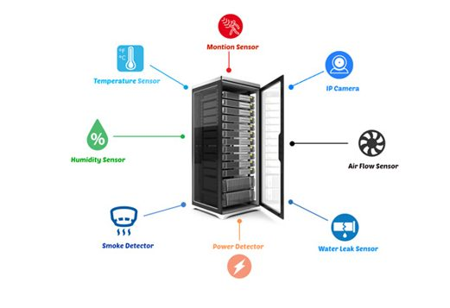

C:\Program Files (x86)\Microsoft Office\MEDIA\OFFICE12\Bullets\BD10263_.gifENVIRONMENTAL MONITORING SENSORS

A monitoring system is easy to install an can be installed by the user even without professional help

C:\Program Files (x86)\Microsoft Office\MEDIA\OFFICE12\Bullets\BD10263_.gifthere are following steps

**C:\Program Files (x86)\Microsoft Office\MEDIA\OFFICE12\Bullets\BD10263_.gif SERVER RACK:**

Base units are usually attached to server where the sensors are installed

**C:\Program Files (x86)\Microsoft Office\MEDIA\OFFICE12\Bullets\BD10263_.gifELECTRONIC OUTLET:**

Must be located near the racks where it is accessible for the basic unit to the plugin

**C:\Program Files (x86)\Microsoft Office\MEDIA\OFFICE12\Bullets\BD10263_.gifINTERNET:**

a fast internet is necessary to run not just the environment monitors but also the whole data center

**C:\Program Files (x86)\Microsoft Office\MEDIA\OFFICE12\Bullets\BD10263_.gifCONNECT AND SET UP:**

The sensors must be intergrated with the based units and the base units to internet for the whole system to work as it should

C:\Program Files (x86)\Microsoft Office\MEDIA\OFFICE12\Bullets\BD10263_.gif**WIRED VS WIRELESS**

C:\Program Files (x86)\Microsoft Office\MEDIA\OFFICE12\Bullets\BD10263_.gif**WIRED SENSOR:**

C:\Program Files (x86)\Microsoft Office\MEDIA\OFFICE12\Bullets\BD10263_.gifMost of the time the wired sensors solution can be what you are looking for this type of sensors can be derictly linked to the base units.

C:\Program Files (x86)\Microsoft Office\MEDIA\OFFICE12\Bullets\BD10263_.gifwired sensors do not need constant replacement which cloud save you some money.but wired sensors also required large space and were more challenging to maintain the more sensors in the facility the harder it gets to maintain

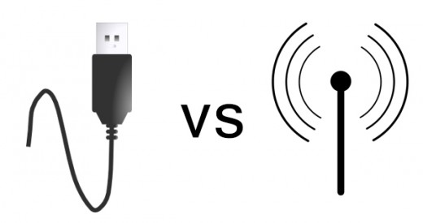

**C:\Program Files (x86)\Microsoft Office\MEDIA\OFFICE12\Bullets\BD10263_.gifWIRELESS SENSOR:**

C:\Program Files (x86)\Microsoft Office\MEDIA\OFFICE12\Bullets\BD10263_.gifwireless monitoring allows a more flexible option for user.it can be programmed depending on the facility’s needs and accessed by multiple users and on-site using mobile gadgets

C:\Program Files (x86)\Microsoft Office\MEDIA\OFFICE12\Bullets\BD10263_.gifwireless sensors also have disadvantage.since they have no wires that directly linked them to the baseunits.the distance cloud hinder if they are not strategically installed.wireless sensors can have difficult in receiving and gathering data if the connection is not strong enough.this make the delivery of data unpredictable

C:\Program Files (x86)\Microsoft Office\MEDIA\OFFICE12\Bullets\BD10263_.gif**TEMPERATURE AND HUMIDITY SENSOR WITH RASPBERRY PI**

C:\Program Files (x86)\Microsoft Office\MEDIA\OFFICE12\Bullets\BD10263_.gifthe DHT22 sensor is ideal for reading the temperature or humidity of your surrounding .before you can use the DHT22 and its chip inside that does analoge to digital conversion,it is important to make the right connections

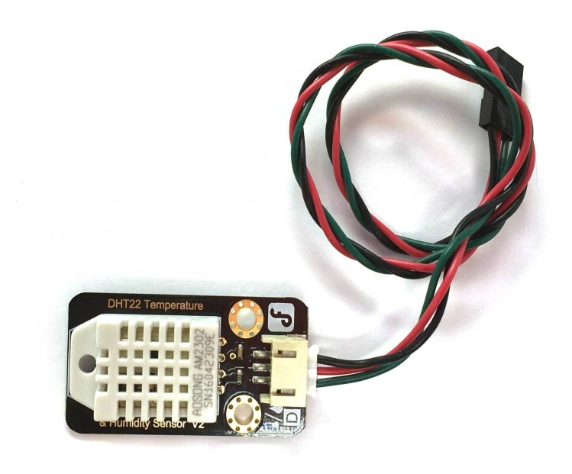

C:\Program Files (x86)\Microsoft Office\MEDIA\OFFICE12\Bullets\BD10263_.gifthe DHT22 is a temperature and humidity sensor.the DHT22 is a basic,low-cost digital temperature and humidity sensor,it uses a capacitive humidity sensor and a thermistor to measure the surrounding air,and spits out a digital signal on the data pin

* **conclusion**

C:\Program Files (x86)\Microsoft Office\MEDIA\OFFICE12\Bullets\BD10263_.gif the environmental monitor can only do wonders if it keeps a full tracking of the a forementioned environmental factors .your data center’s value will also be of greater significance if you run it through an integrated management system .And that’s the type of commitment you need for your data center monitoring endeavors